Issue Mapping Instruction

Issue Mapping Instruction (IMI) is a toolkit for issue analysis. It helps analyse complex issues with multi-stakeholders and puts everyone the same page before and during discussion.

IMI helps lower the threshold for reflection and critiquing by making the information clearer during discussions. IMI consists of three linked segments (see *Figure 1*). The first segment asks participants to clarify the context of the issue, the second segment identifies policy and strategy, and the last segment identifies stakeholders.

It is not necessary to complete IMI in the order presented, but to confirm the relevance of each piece of information. However, this means that the following elements: Problem, Possible Solution, Current Planning and Future Planning should have relevance instead of mutual independence. Please find below the relevance of each filling item (see *Figure 2*).

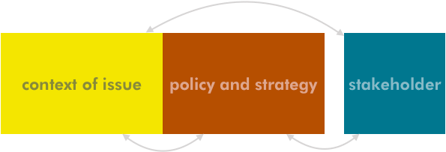

*Figure 1. Three linked segments designed in IMI*

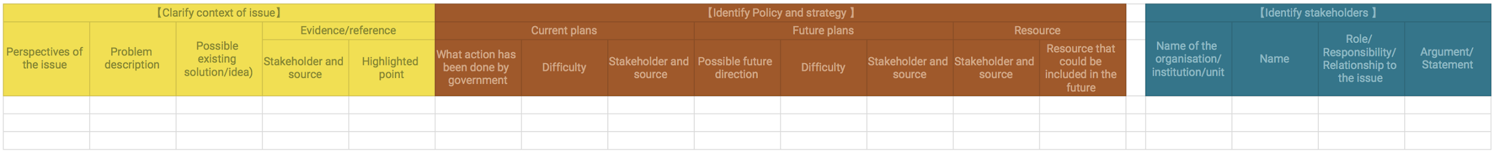

*Figure 2. All columns in IMI*

While IMI is the main method we use before and during the workshop, we also apply supporting tools such as ORID Discussion Method,[1] KJ Method,[2] and Mind Mapping[3]. In addition, we use digital tools such as sli.do[4] to encourage participation and RealtimeBoard[5] to digitise ideas in real time.

*‘Map*,’ as a verb, means *‘to discover or show information about something, especially about its shape or arrangement, or how it moves or works*[6].’ In the process of conducting IMI, we consider the idea of identifying and acknowledging the problems to issues as a process of mapping.

We designed IMI to not only guide the civil servants during the ‘discover’ and ‘define’ stages of tackling complex issues, but also to inspire them to develop their methodologies openly and creatively.

In 2018, we are committed to scaling up the method to another level — where a larger audience can apply it to their everyday life or iterate from the method as a source of inspiration.

|  |  |
| --- | --- |
| Clarify Context of Issue:  Participants are asked to describe and materialise the core problems based on its context and possible solutions in this segment. The participants might find themselves rephrasing the problem description several times before finally reaching the core problem. All filled out content should be grounded with evidence or reference followed by a condensed summary with highlighted points. |  |
| * When having uncertainty, it’s recommended to mark that cell in grey background colour. | |
| Identify Policy and Strategy:  It is essential to understand what the current policies/strategies are related to the problems that are addressed in the first segment and identify possible solutions for the future. It is also important to discover potential resources such as technology, people, organisation, corporation, budget, regulation...etc. |  |
| Identify Stakeholders:  When identifying stakeholders, it is important to maintain the stakeholder groups’ diversity and representativeness. The participants will be suggested to draw information from previously written reference and search for relevant organisations, institutions, and units. |  |

___________________________________________

Issue Mapping Instruction (IMI) Version 7.5

July 2018

[pdis.nat.gov.tw](https://pdis.nat.gov.tw)

[po.pdis.tw](https://po.pdis.tw/)



This work is licensed under a Creative Commons Attribution 4.0 (CC BY 4.0) International license.

1. <http://www.plannersconference.com/pdf/sessions2012/Top%20Participatory%20Facilitation%20Lab_115.pdf>
2. <https://en.wikipedia.org/wiki/Affinity_diagram>
3. <https://en.wikipedia.org/wiki/Mind_map>
4. [https://sli.do](https://www.sli.do/)
5. <https://realtimeboard.com>
6. <https://www.ldoceonline.com/dictionary/map#map__5>, access at February 7th 2018.